IPO Setup—Purchase Order Settings (IPOD)

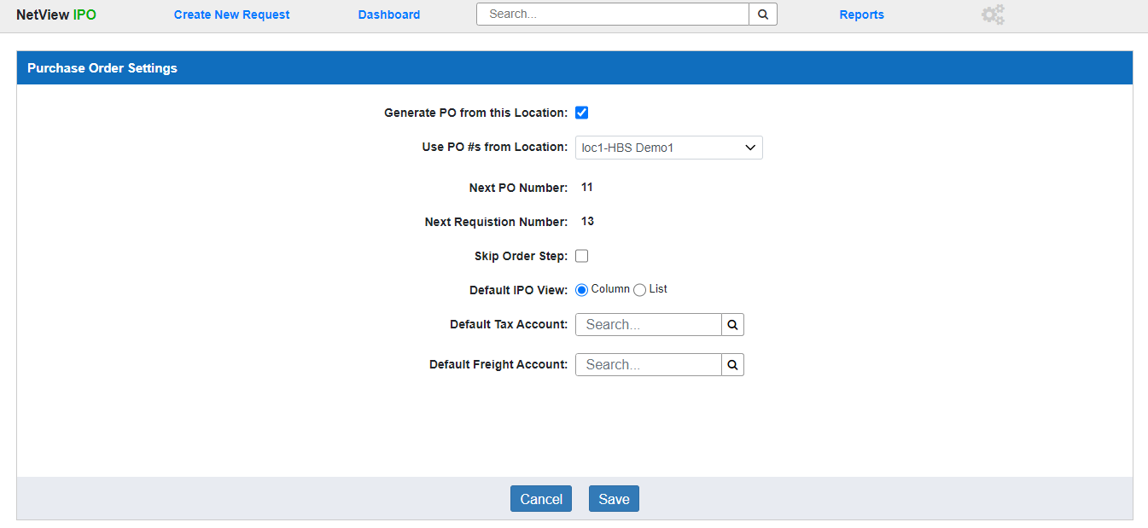

The Purchase Order Settings screen in Integrated Purchase Orders (IPO) manages specific preferences and provides certain information about how IPO will work in a dealer location. This screen can only be accessed by the **system administrator** (without requiring an IPO role). **NOTE:** The settings only apply to the **current Desktop location**; you will have to switch your Desktop to a different location in order to change that location’s settings.

To access the settings screen, open IPO and then click the header icon shaped like three interconnected gears:



You can also type “IPOD” in the Shortcuts Bar to directly open IPO to this screen.

**Field Definitions:**

Generate PO from this Location: If you want this location to be able to create purchase orders, check this box. **You will not be able to use IPO in this location if you do not check this box.** If the box is left unchecked, all other fields in this screen will be **disabled**, as will the “Create New Request” option in the program header.

Use PO #s from Location: This setting controls which location’s auto-generating Requisition/PO number system the current location will follow (i.e. share with that location and any others marked similarly). For example, setting “Consolidated” in Location A means both the Consolidated location and Location A will use the same system of Requisition/PO numbers. So if you create Requisition #10 in the Consolidated location, then create a new Requisition in Location A, that Requisition will automatically be #11, and the next Requisition you create in either location will be #12

Next PO Number: This shows the document number that will get assigned to the next purchase order you create.

Next Requisition Number: This shows the document number that will get assigned to the next requisition that you create.

Skip Order Step: With the exception of **Unit Type POs**, the Order step is largely just for tracking purposes or in case the actual order differs from what was recorded on the requisition. Check this box if you want this location to skip performing the Order step on **non-Unit Type** purchase orders, moving straight to the Receive step from creating the purchase order. If you choose this, the program will assume that the entirety of the purchase order was ordered with no changes from what was originally requested, and will record those values for the required Order information in order to proceed.

**Order Step in Unit Type POs:** This setting does **not** affect Unit-Type POs, as the Order step is **always** necessary on that order type. This is due to how the program works with the Units package in order to properly create records for the units.

Default IPO View: This setting controls what Dashboard view will appear by default when a user first opens IPO at this location. Select either **Column** or **List**.

Default Tax Account: This setting sets a default account to receive any amounts specified as tax on **General Type POs** only. Enter the desired account or search for it using the Account Lookup.

Default Freight Account: This setting sets a default account to receive any amounts specified as freight on **General Type POs** only. Enter the desired account or search for it using the Account Lookup.

**Cancel:** Click this button to go to your default Dashboard screen without saving any changes to your settings.

**Save:** Click this button to save any changes to your settings and go to your default Dashboard screen.